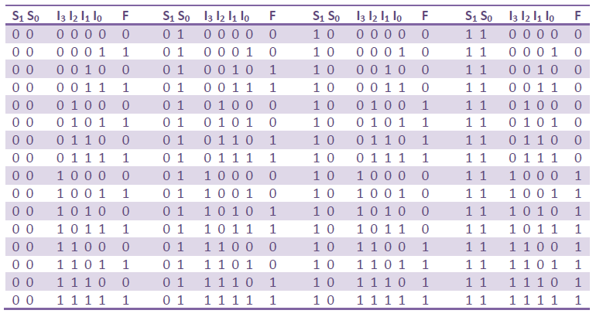

Truth table of 4 to 1 mux